Welcome to the third edition of the South of England Equality & Diversity Newsletter. Thank you to those who were happy to contribute information about events, campaigns and sharing good practice across the region. Remember, if you would like to request the inclusion of an article in any forthcoming editions, please contact Harry Connery. Please see the last page below for Harry’s contact details.

New Equality Delivery System (EDS) support arrangements in the South West

Please note that in order to support the continued high level of implementation of the EDS during the transition period it has been decided that each SHA Equalities team member will work more closely with a number of clusters in the South West. The new EDS support arrangements are as follows:

Rhea Brooke (01823 361258, rhea.brooke@southwest.nhs.uk) : Cornwall and the Isles of Scilly cluster; Devon, Plymouth and Torbay cluster; South Western Ambulance Trust;

Harry Connery (01823 361258, harry.connery@southwest.nhs.uk ): Somerset cluster; Bristol, North Somerset and South Gloucestershire cluster; Avon and Wiltshire Mental Health Partnership NHS Trust;

Michail Sanidas (01823 361209, Michail.sanidas@southwest.nhs.uk) : Gloucestershire and Swindon cluster; Bath and North East Somerset and Wiltshire cluster; Dorset, Bournemouth and Poole cluster; Great Western Ambulance Service.

We look forward to working with you over the next few months.

Rhea, Harry and Michail

Rhea, Harry and Michail

Kernow Clinical Commissioning Group
Developing an Equality and Human Rights Strategy.

Kernow Clinical Commissioning Group (KCCG) which covers the whole of Cornwall and the Isles of Scilly are developing an Equality and Human Rights Strategy to ensure that this important area of work is embedded into the culture of the new organisation. The strategy commits to ensuring that healthcare is fair and accessible for the whole population, and states that the organisation will use the Equality Delivery System to help achieve this. It details the Equality Objectives KCCG have set, and commits to working in partnership with public and voluntary sector partners so that there is an equitable and comprehensive services for the whole population. KCCG is participating in the national NHS Equality Partner’s programme during 2012-13 and it is hoped that the learning will help it to become an equality and human rights based organisation. If you would like to know more about the strategy please contact Kate Milton by email- kate.milton@ciospct.cornwall.nhs.uk

National LGBT Health Summit 2012

 The 2012 LGBT Health Summit will be held in Canterbury, Kent at the University of Kent on 13th & 14th September.

It is being hosted by the LGBT Health Summit 2012 Consortium, the successful bidding partnership headed up by Metro, Kent Community Health NHS Trust, Kent Transgender Forum and the Centre for Gender, Sexuality and Law, University of Kent. It represents a real partnership approach to ensuring that the Summit has both national and local significance, relevance and impact.
To find out how you can get involved in the summit click here

Insight into ill -treatment in the workplace: patterns, causes and solutions.
Funded by the Economic and Social Research Council and supported by Acas and the Equality and Human Rights Commission, this report { by Ralph Fevre, Duncan Lewis, Amanda Robinson and Trevor Jones} provides an authoritative account of workplace ill treatment in Britain.
Using evidence from nearly 4,000 face to face interviews and four organisational case studies, including a large NHS Trust, the report explores the causes of ill treatment and suggests some solutions.
To read the report and the results from the British Workplace Survey click here

White Vans are good for Men’s health…
During Men’s Health Week {11-17June} a white van toured Bristol targeting a few, key locations where men work and socialise to deliver important health messages. In exchange for submitting to a health check or advice session, men received a copy of the Bristol MANual of Health. Written in an easy read style and adopting the language of a car maintenance workshop the MANual has a “one-stop shop” approach, covering nine key health topics.
Over 250 people were spoken to during the week, and 177 health check questionnaires were conducted. From the different health issues discussed, the following were found to be typical behaviours:

- It’s difficult for men to find time to go and see their GP (and many miss follow up appointments due to work commitments)

- Partners are the push that men need (lots of wives and girlfriends “forcing” men to get their blood pressure checked)

- Men will happily talk about their health when given the opportunity, even in an open public space (Car park/lobby/café/platform/park)
According to Health Promotion Specialist Sam Hayward, “Many of the men we spoke to already knew about healthy lifestyle choices, knowing about advice on healthy eating, physical activity, smoking and alcohol and the majority of these were planning on making positive health choices in their near future. Hopefully with the advice and conversations we had these men will be pushed to make these changes”

To find out more about the campaign and about the Bristol MANual of Health please contact : David Harris, Senior Equality Advisor at NHS Bristol: David.Harris@bristol.nhs.uk

2011 Census, Population and Household Estimates for England and Wales
On census night the population in England and Wales was 56.1 million, 53.0 million in England and 3.1 million in Wales. This was the largest the population had ever been.
To see the latest household estimates, and population estimates by age and sex, for England and Wales please click here

The BME Leadership Forum
Diary dates,
At the NHS Employers Equality, Diversity and Human Rights London Conference in May 2012 a new leadership team which will steer the BME Leadership Forum’s work programme, introduced themselves: Maxine James, Chair of the Forum, is supported by two vice chairs. Jagtar Singh OBE and Dr Nola Ishmael OBE. The BME Leadership Forum holds three half-day forums each year to update members on current work and initiatives and provide a platform to engage with key policy makers and opinion formers.
The dates of the Forum's meetings are as follows.
18 October 2012
7 February 2013
24 April 2013

Any enquiries regarding joining the forum or about the work of the Forum please contact Christina Heap at: Christina.Heap@nhsconfed.org

Project Search
Supporting Individuals with Learning Disabilities

Congratulations to Jayne Middleman, Organisational Development Facilitator at Plymouth Hospitals NHS Trust for continuing to support Project Search. Originally developed in the USA , the project has been running for several years now and the Plymouth Project Search programme is a college-to-work internship for students with learning disabilities. The goal for each student is competitive employment in the community using the skills they have acquired following an internship at the Trust.
- To find out more about the success of the current project please go to: www.youtube.com/watch?v=IkA0RBeHGRY

2011 Census, Population and Household Estimates for England and Wales
On census night the population in England and Wales was 56.1 million, 53.0 million in England and 3.1 million in Wales. This was the largest the population had ever been.
To find out more about the first release of 2011 Census data which provides household estimates, and population estimates by age and sex, for England and Wales click here

Mary Seacole Memorial Statue Appeal
Funds are being raised for a memorial to Mary Seacole in the grounds of St Thomas Hospital, London. The memorial is the first of its kind to a named black woman in the United Kingdom and it is believed that it will acknowledge the important role played by ethnic minorities in British history and the success of our multi-cultural society. The artist Martin Jennings has been chosen to design the memorial and planning permission has been granted by Lambeth Council. However help is needed to raise £500,000.00 to create the memorial. To date £150,000.00 has been received in donations but £350,000.00 is still needed.

To find out more about Mary Seacole or to make a donation please visit the website: www.maryseacoleappeal.org.uk

Dorset-based Olympics legacy exhibition project challenges homophobia:
A broad coalition of organisations including NHS Trusts, local councils, colleges, Bournemouth university academics, the Students Union, Equality South West and a number of Dorset and south west England LGB&T groups, have been brought together to support an anti-homophobia exhibition project in the Dorset area.

“The original impetus for the project,” says Alan Mercel-Sanca, the project lead and chairperson of the Oriental Culture Educational Society, “was the extent of still largely unchallenged homophobia in UK schools, especially in a sports/PE context but we looked at other areas where LGBT discrimination is common, including in public service organisations such as the NHS”.

With the forthcoming Olympic Games showcasing how international sport and athletics can bring people together irrespective of race, culture, gender and sexual orientation, it was felt to be the ideal time to start work on the exhibition.

A launch event will be held at Bournemouth Library on Tuesday 7th August. VIP’s attending include Mr Michail Sanidas, NHS South of England Equality and Human Rights Manager.

The projects information resources and graphic design images are available online at:www.ahs-exhibition2012.co.uk

If you want to find out anything else about the exhibition please contact project lead: Alan Mercel-Sanca at
oces.contact@gmail.com
£19 million looking to be invested in health and social care enterprises.

The Social Enterprise Investment Fund (SEIF) is looking to invest £19 million in health and social care enterprises delivering exceptional value through their services.

From Monday 2 July till noon on 24 August 2012, emerging and existing social enterprises demonstrating high social impact can apply for funding packages that will help them grow. This includes funding to help build commercial capability and support for those spinning out of the public sector.

At least £8 million will be available in the form of loans. Capital and revenue grants between £30,000 and £150,000 are also on offer

If you would like to find out more about the funding packages available please email: seif@local.gov.uk or telephone Local Partnerships to discuss eligibility on 02071877379.

Welcome To Rhea!
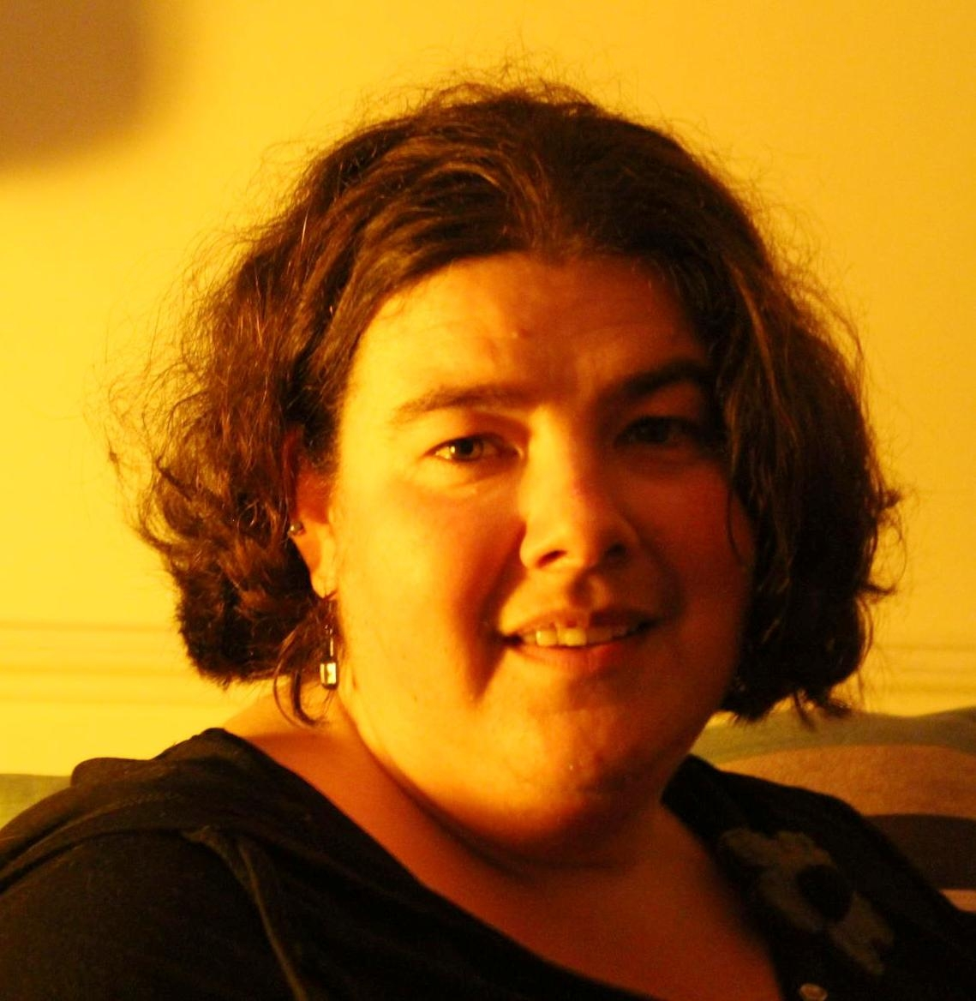 We can now officially welcome Rhea Brooke to our SHA Equalities Team. Rhea has joined NHS South as an EDS Project Officer . With much experience in tackling Equality and Diversity issues from her work with community based organisations in Plymouth Rhea is looking forward to supporting the southernmost cluster in the south west {this includes Cornwall and the Isles of Scilly cluster; Devon, Plymouth and Torbay cluster and the South Western Ambulance Trust}.

Away from work Rhea enjoys photography, eighties music and is a keen cat lover-having taken in several waifs and strays over the years!.

We wish Rhea well in her new role.



Berkshire Healthcare NHS Foundation Trust chosen as Equality and Diversity Partner
Berkshire Healthcare NHS Foundation Trust (BHFT) is one of 12 NHS organisations that has been chosen by NHS Employers to be an Equality and Diversity Partner.
The Equality and Diversity Partners work programme supports participating trusts to progress and develop their equality performance and to build capacity in this area. At the same time the programme provides an opportunity for Partners to offer advice, guidance and demonstrations of good practice in equality and diversity management to the wider NHS.
Stef Abrar, Equality and Diversity Co-ordinator for BHFT said, “We supported our application to become an NHS Employers Equality and Diversity Partner with substantial evidence that we are embedding equality, diversity and human rights into every aspect of the core business of the organisation. As an Equality and Diversity Partner, we will contribute to the NHS Employers programme of work and will help spread good practice, learning and expertise throughout the NHS “.

For further information about BHFT’s commitment to the partnership programme please contact Stef Abrar, e’mail: Stef.abrar@berkshire.nhs.uk

Dates for your diary… 
20 July Beginning of Ramadan

23July Emperor Haile Selassi I birthday

1August Unconscious Bias Workshop
{ENEI Offices}

3 August Inspiration4ability {UWE Bristol}

10August Krishna Janmashtami

12August International Youth Day

19-21 August Eid al Fitr- Ramadan ends

23 August International Day -remembrance
of Slave Trade & abolition

If you would like to give feedback about this newsletter or submit an article to go in the next edition, please contact Harry Connery via harry.connery@southwest.nhs.uk


